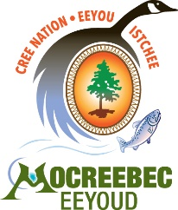 | MOCREEBEC EEYOUD  INDIVIDUAL MEMBERSHIP APPLICATION (18 YEARS +)

Personal Information
First name:
Middle name(s):
Last Name:
Date of Birth (MM/DD/YYYY):
Band Name & Number:
Beneficiary Number:
Name of Quebec Affiliation:
Family Clan (if known):
Home Address:
Home Phone: | Cell:
E-mail address:

I, ______________________________________________, hereby declare that:

- I am, or I am a descendant of a “Y” dialect Cree-speaking person, or I am a spouse, or an adopted child of such a person, and;

- I am committed to the principles, purpose and objectives of the MoCreebec Constitutional Framework, ratified June 6, 1993.

_____________________________ _________________________
Signature of Applicant Date Signed

_____________________________ _________________________
Signature of Witness Date Signed

